- Solve the proportion. Show your work. $\frac{3}{x + 1}$ = $\frac{5}{11}$
Solution
3(11) = 5(x+1)
33=5x+5
33-5=5x
28=5x
X=$\frac{28}{5}$

- The figures in each pair are similar. Find the value of each variable. Show your work.

- 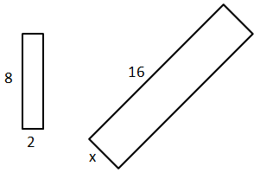
If they are similar by sides, then
16/8=2
Then 2*2=4
X=4

- 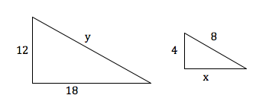

If they are similar by sides, then
12/4=3
Y=8*3=24
X=18/3=6
Y=24
X=6

- Determine whether the triangles are similar. If so, write a similarity statement and name the postulate or the theorem you used. If not, explain.

- 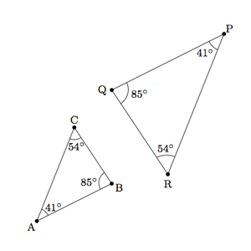

- 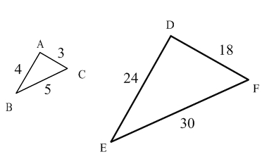

Since the triangles have no angles we try their sides fraction
24/4=6 18/3=6 30/5= 6
The sides are proportional so the triangles are proportional.
Therefore, Triangle ABC= Triangle DEF
By the Side-side principal
If two angles of one Triangle are congruent to two angles of another triangle, then triangle are said to be similar but The ORDER is essential
Then Triangle ABC=Triangle PQR by the above principle

- Find the value of each variable for the right triangles. Make sure all answers are in reduced radical form. Show your work.

  - 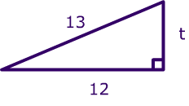
  - 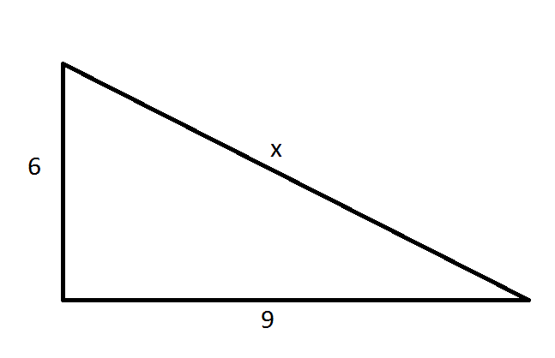

b) h=$\sqrt{t^{2}+p^{2}}$
h=$\sqrt{9^{2}+6^{2}}$
$\sqrt{117}$= 10.82
- h=$\sqrt{t^{2}+p^{2}}$
t=$\sqrt{h^{2}-p^{2}}$
t=$\sqrt{{13}^{2}-{12}^{2}}$ =$\sqrt{{169}^{2}-{144}^{2}}$

$\sqrt{25}$ =5

- Given the following triangle side lengths, identify the triangle as acute, right or obtuse. Show your work.

  - 5 in, 6 in, 7 in

  - 18 in, 9 in, 12 in

- p=5, q=6 and r=7
p² + q² = r² 5² + 6² = 61,, 7²=49
and r² < 61
41<61
Acute
.
Let the sides P, Q, R
The following properties applies
$p^{2}+q^{2}=r^{2}$ Right Angled Triangle
$p^{2}+q^{2}>r^{2}$ Acute Triangle
$p^{2}+q^{2}<r^{2}$ Obtuse Triangle

b) p=18, q=9 and r=12
p² + q² = r² 18² + 9² = 405,, 12²=49
and r² < 405
144<405
Acute

- Find the missing value. Show your work. Round to the nearest hundredth.

  - 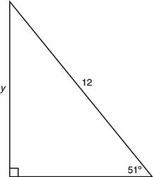

  - 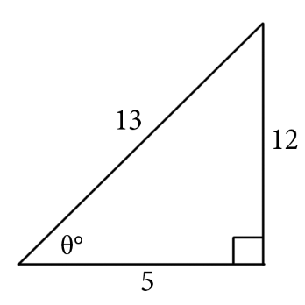

  - 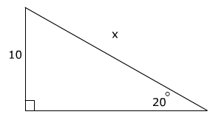

SOHCAHTOA
Sin $θ$ =$\frac{opposite}{Hypotenuse}$
Sin $θ$ =12/15
Sin $θ$=0.8
$θ=\sin^{-1}0.8$ =53.13⁰

SOHCAHTOA
Sin $θ$ =$\frac{opposite}{Hypotenuse}$
Sin $θ$ =x/10
X=10 sin $θ$
x=10sin 20
x=3.42

SOHCAHTOA
Sin $θ$ =$\frac{opposite}{Hypotenuse}$
Y Sin $θ$ =12
Y=$\frac{12}{Sin θ }$ Y=$\frac{12}{Sin 51 }$ y=15.44

- Given the vertices of ∆ABC are A (2,-5), B (-4,6) and C (3,1), find the vertices following each of the transformations FROM THE ORIGINAL vertices:

  - R_{x = 3}

  - T_{<3,-6>}

  - r_{(90◦, o)}

B T(3, -6) is the translation of the original triangle ABC three units right and six units down. The new coordinates would be A'(5, 1), B'(-7, 0), and C'(6, -5)

R(x=3) is the reflection of the original triangle ABC on the line with equation x=3.
The new coordinates would be A' (2, 1), B' (4, 0), and C' (3, 5)

cr_{(90◦, o)}
r(90°, 0) is the rotation of the original triangle ABC on the origin by 90° clockwise. The new coordinates would be A'(5, -2), B'(6, -4) and C'(1 -3)

- Find the congruence transformation that maps ∆ABC to ∆A’B’C’. Explain.
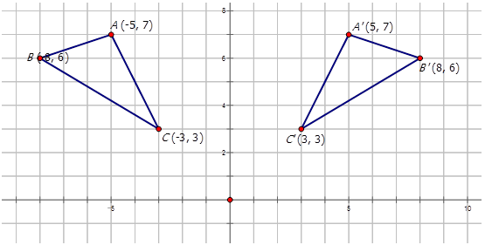
The transformation is a reflection on the y-axis.

If we take the y-axis as the mirror line as shown in the diagram above, it is clear that distance of vertices A, B, and C to the mirror line are equals to the distance of vertices A', B' and C' to the mirror line.

- Find the area of each figure to the nearest tenth.

  - 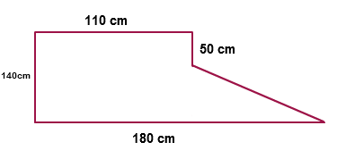
Area of Trapezium
DE 10²-8² =$\sqrt{36}$ =6
Area of Trapezium $\frac{a+b}{2}h$
Area of Square 8*8=64 ft² triangle 0.5*6*8=24 ft²
88ft²
We splint the figure into rectangle and Triangle
Area rectangle=110*140=15,400 cm²
Triangle=0.5*70*90=3,150 cm²
15,400+3,150=18,550 cm²
  - 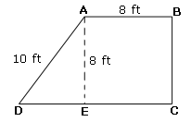

- Find the measure of both arc AB and arc APB, where <APB = 108◦. Please be sure to show your steps.
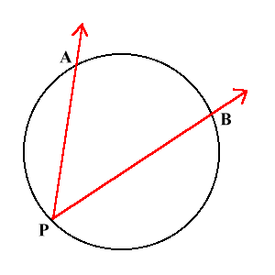
∠APB is an inscribed angle
The measure of the intercepted arc is twice that of the inscribed angle ⇒
arc AB = 2 * ∠APB = 2 * 108 = 216°

- Find the area of a regular Octagon with side lengths 5in. Round your answer to the nearest tenth.

Area of area of a regular Octagon = A=2(1+2) * a²

A=2(1+√2) *a²=2*(1+√2) *5²=120.71068

=120.7 in²

- Find the surface area of each figure to the nearest tenth.

  - 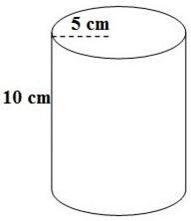 b. 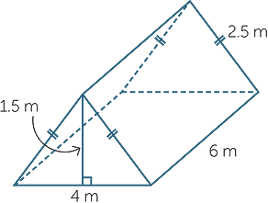

Triangular prism
SA = (a + b + c) h
where a, b, c are the sides of the triangle and h is the length of the prism
a = 4 m b = c = 2.5 m h = 6 m
SA = (4 m + 2.5 m + 2.5 m) 6 m
SA = 54 m²

The formula for surface area of cylinder is: SA = 2 π r h
where r = 5 cm and h = 10 cm
SA = 2 π (5 cm) (10 cm)
SA = 100 π cm²= 314.16 cm²

b. What is a real-world example or use of surface area?

- Find the surface area of each figure to the nearest tenth.

  - 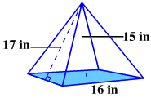

  - 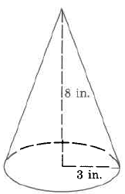

A = πr (r + h² + r²)
8 in and r is the radius = 3 in
A = π * 3 (3 + sqrt (8^2 + 3^2))
A = 34.63π in²= 108.8 in²

Base Area = 16*16 = 256 in²
Perimeter= 16*4 = 64 in
LSA = (64*17)/2 = (64*17)/2 = 1088/2 = 544 in²
TSA = 544+256 = 800 in²

- Find the volume of each figure to the nearest tenth.
Sphere volume:
V = 288π = 288*3.14 = 904.3 m³

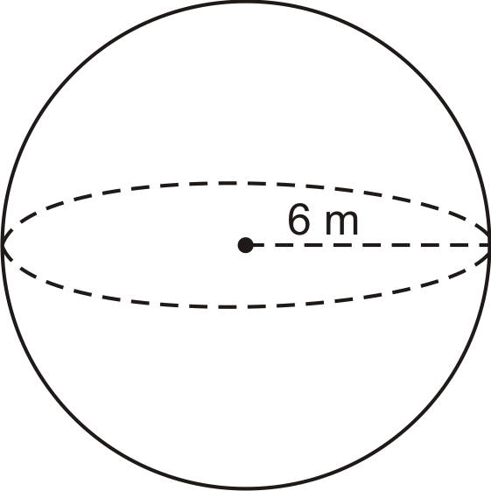

Height 13²-5²=$\sqrt{144}$ =12
Cone volume:
V =
(300*3.14)/3 = 942/3 = 314 m³

  - 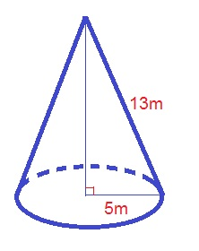

Volume = b*w*h
6cm*5cm*11= 330cm³

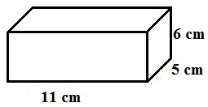

- Find the center and radius, then write the standard equation of each circle

a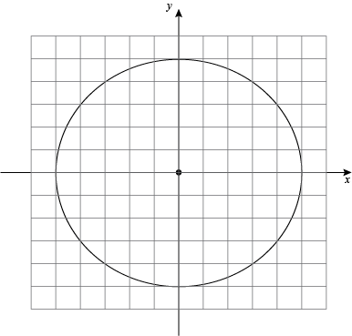

b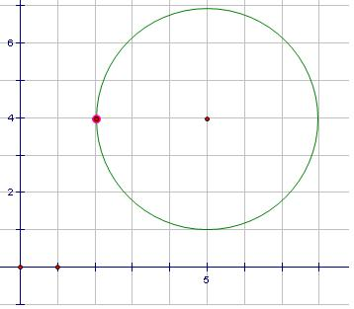

Center =origin
Radius = undefined
r²=x²+y²

Centre = (6,4)
Radius = 3 units
(x-6)²+(y-4)²=3²
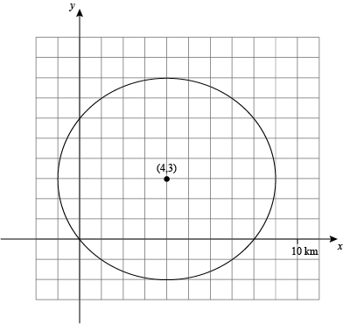
Radius = 5 units
Centre= (4,3)
(x-4)²+(y-3)²=3²

18. Solve for x

a.
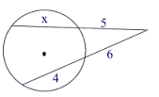
5(5+x) = 6(6+4)
25+5x = 60
5x = 35
x = 7

b.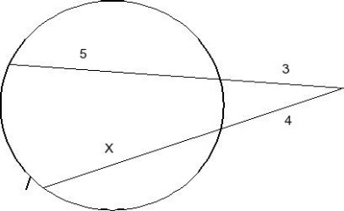
3(3+5) = 4(4+x)
24 = 16 + 4x
4 x = 24-16
4x = 8
x = 2

- Evaluate

  - 6!
6! = 1*2*3*4*5*6 = 720

  - ₈P₅

  - ₁₂C₄

combinations s we have n! /(n-r)! r!
12! / (12-4)!4 !=12!/8!4!= 285,120
permutations we use the formula n!/(n-r)!
so we have 8!/(8-5)!=8!/3!=6720

- Use the spinner to find each theoretical probability
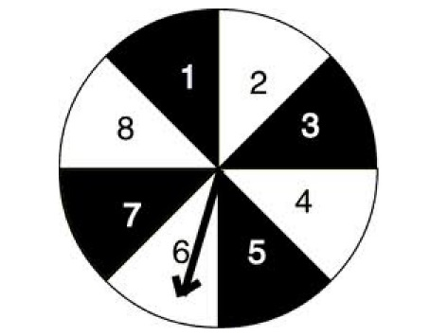
  - P (a number no more than 5) it says no more than 5 so that includes 5, so there are 5/8 probability
  - P (an even number) since this spinner stops on an even number (8) that means half are even and half are odd so 4/8, but you can reduce that to 0.5
  - P (a number less than 3) since it says less than 3 there are only two so that ends up being 2/8 or 1/4 probability

- You roll two standard number cubes. What is the probability that the sum is odd,
given than one of the number cubes shows a 4?
If one is already rolled as a 4, then there are only 6 other total combinations to get.
so what are sums to get an odd number?
4+1=5
4+3=7
4+5=9
so you have a 1/3 chance of getting an odd number, given that one of the dice is already a 4.

- What is the area of the figure:

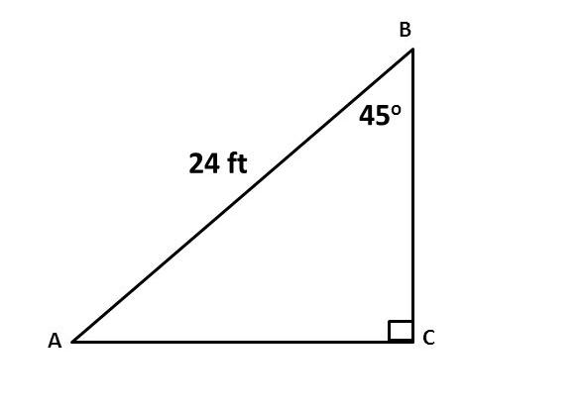
SOHCAH TOA
Sin 45= x/24
24sin 45=x
X=16.97
Y= 25cos45= 17.68
0.5*17.68*16.97=150ft²

